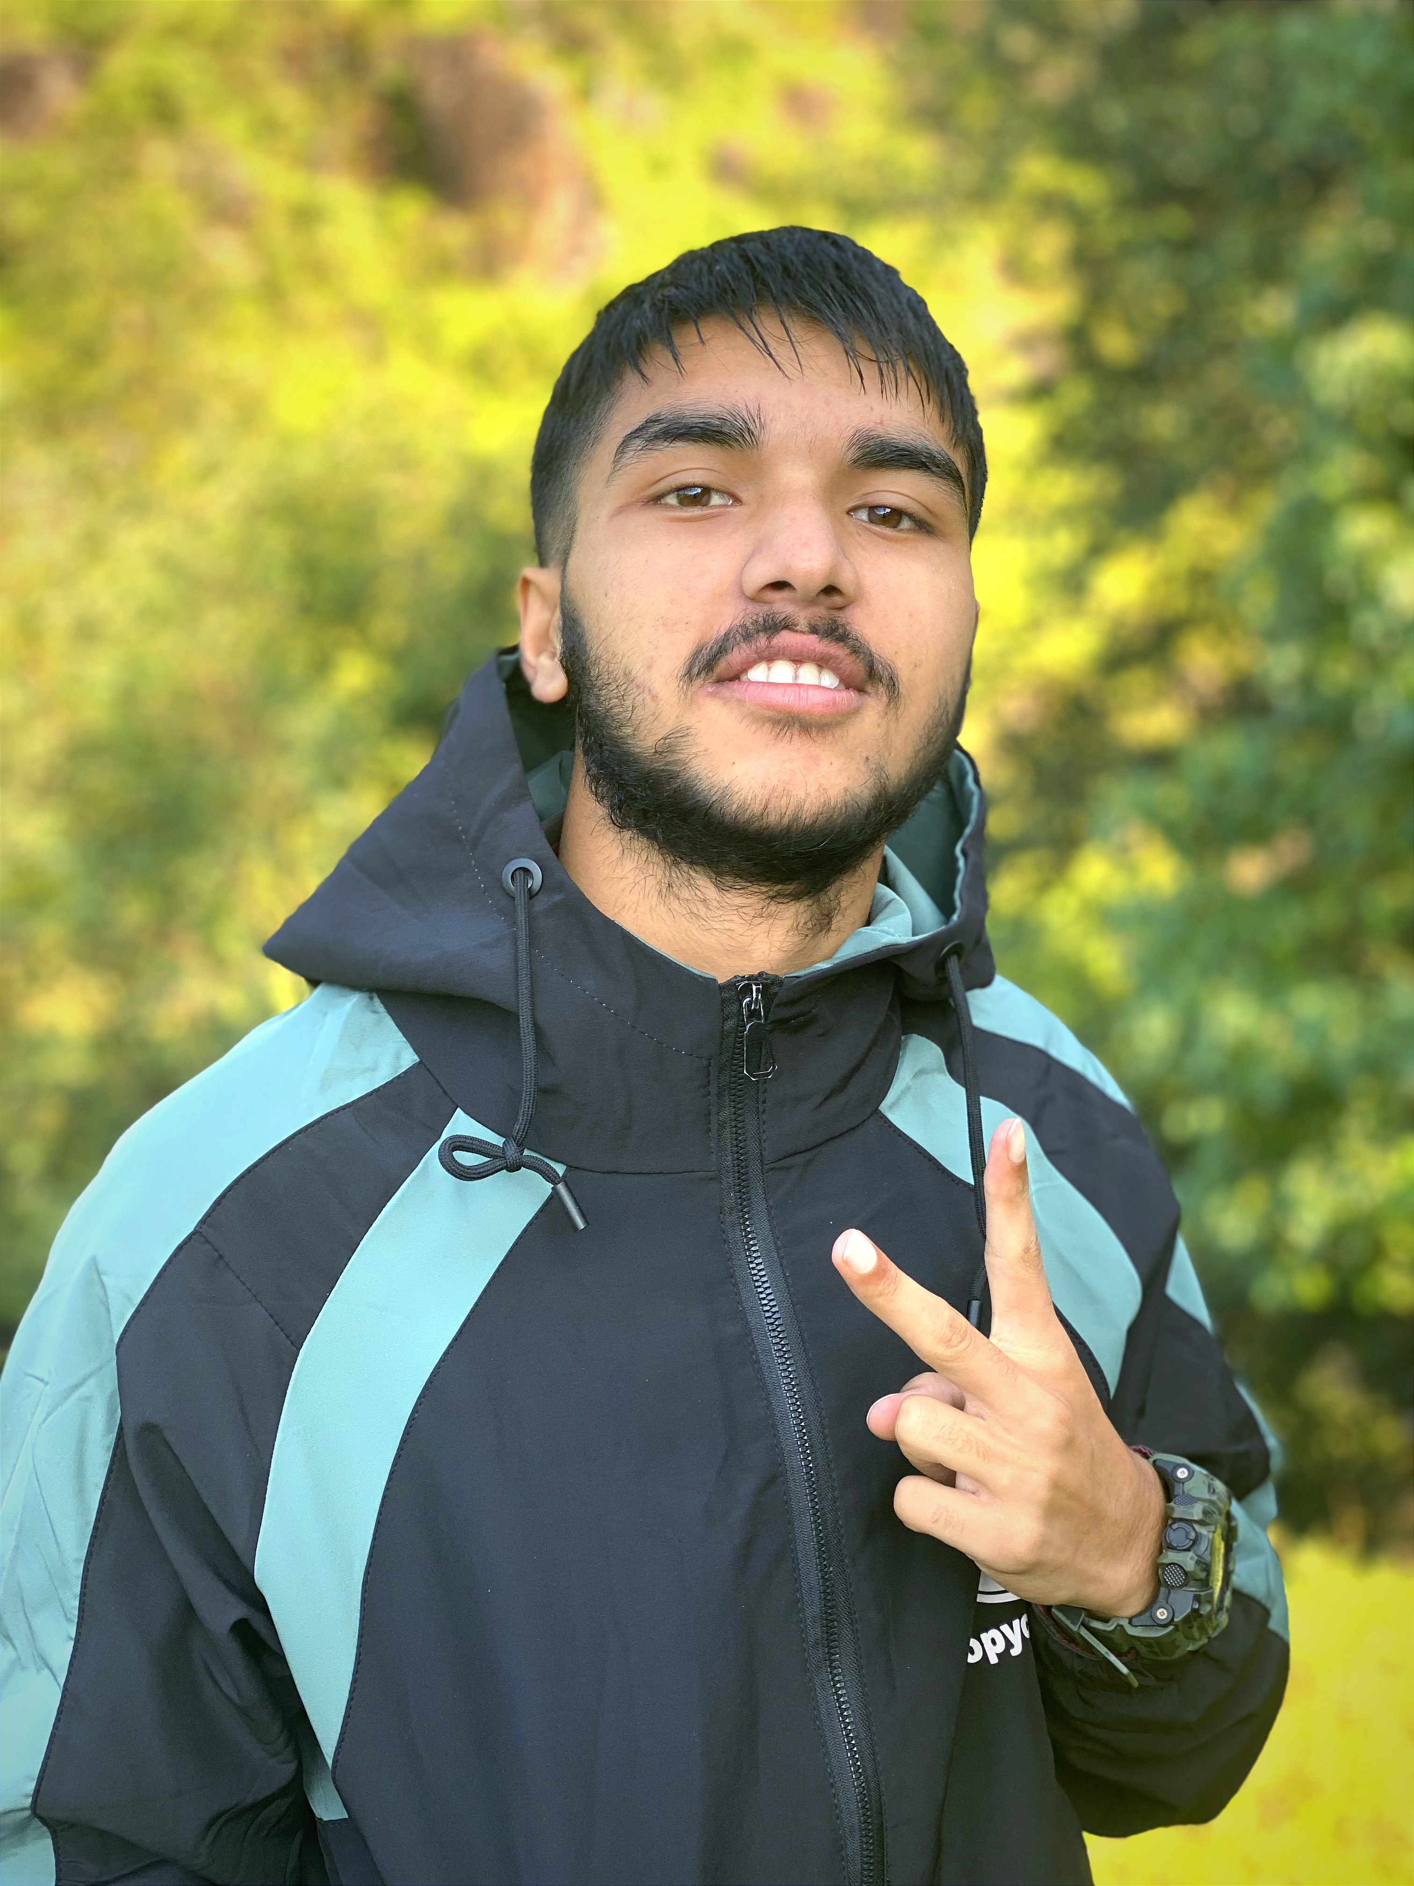

**BIPAN NEUPANE**

**DIPLOMAS Y HOBBIES**

**Formaciones :** Diplomados, Congresos, xxxxxxxxxx xxxxxx xxxxxxxxx xxxxxxxxxxxxxxxxx

**Hobbies:** xxxxxxxxxxxxxxxxxxxxxxxxxxxxxx





Highly motivated student looking to leverage classroom knowledge in real-world scenarios and contribute to meaningful projects.

+977-9824171155 Bipanneupane18@gmail.com

Doodhpokhari-02, Lamjung,

Nepal.





**EDUCATION**

**PERSONAL SKILLS**

**SHREE BAGISHWARI SECONDARY SCHOOL**

* Decision-Making
* Leadership
* Collaboration
* Problem Solving
* Communication
* Team work

**SOUTHWESTERN STATE COLLEGE**

Completed in year 2021. | (Doodhpokhari-02, Lamjung)

Completed SEE(10th standard) with GPA 3.85 ( i.e, Grade A+). Extracurricular activities included drawings and quiz.

**TECHNICAL SKILLS**

* Basic knowlede of HTML & CSS.
* Good Knowlege of C/C++ programming
* Software proficiency in MS Word, Powerpoint,Excel,Google drive Etc.
* Basic knowledge of Graphic Designing Using Adobe Photoshop.
* Good knowledge of Nepali Typing.

Nepali

Hindi

English

**Document Controller -Full Time | Marga Darshan HR.**

Graduated with GPA 3.58 (i.e, Grade A) Majoring in Science(Physics) and was Vice president and Treasurer in SWSC Robotics and Astronomy & Astrophysics Club (2021-2022). Extracurricular activities included Report Writing.

©AZURIUS - My-resume-templates.com

* Star Gazing
* Climbing
* Reading Self help books
* Solo Travelling

Completed in year 2023. | (Basundhara, Kathmandu)

**EXPERIENCE**

2023 (Tokha-05,Basundhara, Kathmandu)

In charge of documentation, inquiries handling, and data entry.

**INTERESTS**

**LANGUAGES**